Practical No: 05

VIII. Resources required (Additional)
- if any web references are required.

Resources used (Additional)
  - https://docs.microsoft.com/en-us/dotnet/visual-basic/language-reference/statements/select- case-statement
  - https://www.tutorialspoint.com/vb.net/vb.net_select_case_statements.htm

Program Code:
Write a Program using select case statement in VB.NET
Module Module1 Sub Main()
Dim grade As String Console.WriteLine("Enter Your grade") grade = Console.ReadLine()
Select Case grade Case "A"
Console.WriteLine("High Distinction") Case "A-"
Console.WriteLine("Distinction") Case "B"
Console.WriteLine("Credit") Case "C"
Console.WriteLine("Pass") Case Else
Console.WriteLine("Fail") End Select
Console.ReadLine() End Sub

End Module

Results (Output of the Program)
Enter Your grade A
High Distinction

Practical Related Questions
- Write the use of Select Case statement –
  - A Select Case statement allows a variable to be tested for equality against a list of values.
  - Each value is called a case, and the variable being switched on is checked for each select case.

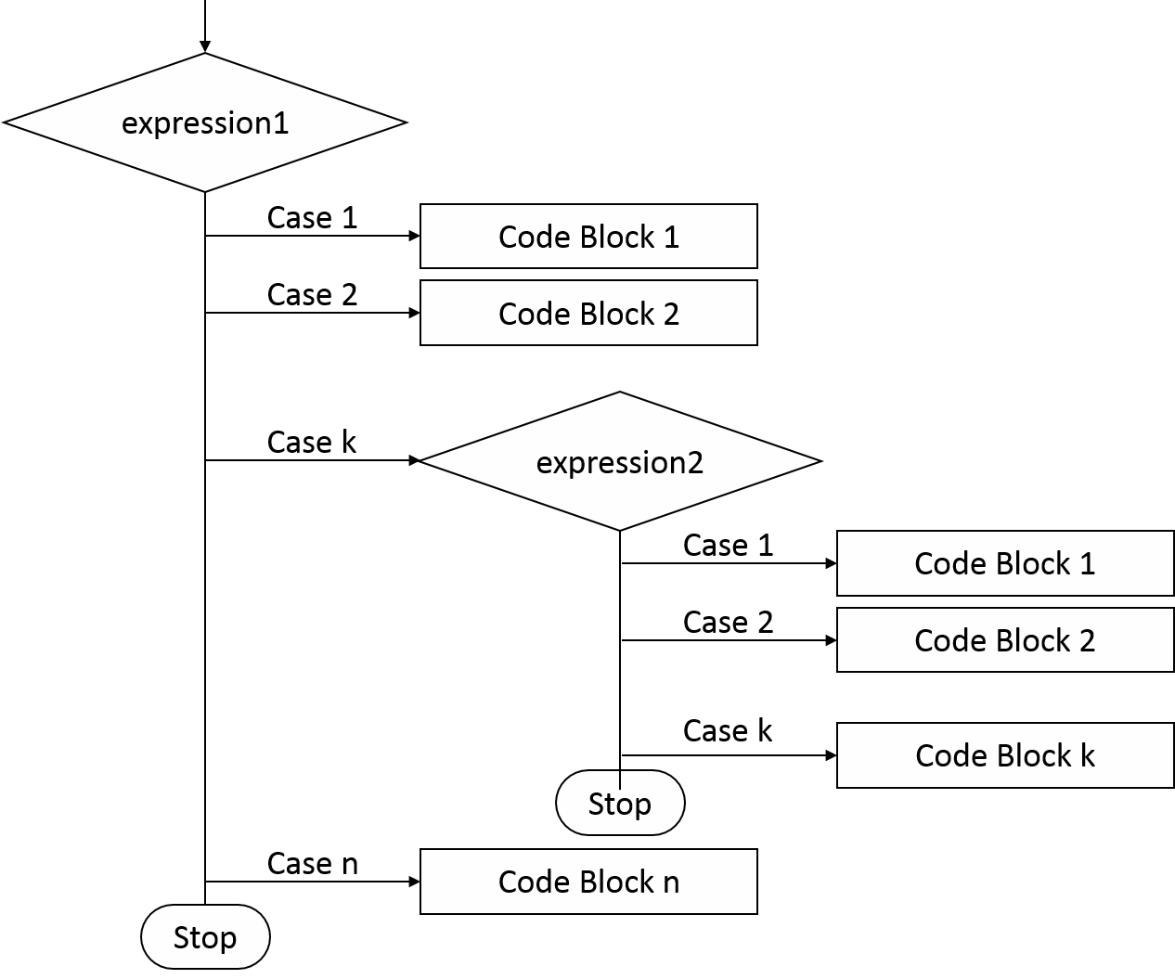Flowchart for nested Select Case statement –

- rcise

- Implement the program using Select Case statement to count the number of Vowels in A to Z alphabets.
- Module Module1
Sub Main()
Dim str As String = "ABCDEFGHIJKLMNOPQRSTUVWXYZ"
Dim numberOfVowels As Integer = 0

For Each c As Char In str Select Case c
Case "A"c, "E"c, "I"c, "O"c, "U"c
numberOfVowels = numberOfVowels + 1 End Select
Next

Console.WriteLine("Number of vowels: " & numberOfVowels) Console.ReadKey()
End Sub End Module Output:

Number of vowels: 5

- Develop a program for performing arithmetic operations –
Module Module1 Sub Main()
Dim N1, N2, Result, choice As Integer Do
Console.WriteLine("Menu:-\n1.Add\n2.Subtract" & _
"\n3.Multiply\n4.Divide\n5.Exit.")
Console.WriteLine("Enter choice: ") choice = Console.ReadLine() Console.WriteLine("Enter number 1: ") N1 = Console.ReadLine() Console.WriteLine("Enter number 2: ") N2 = Console.ReadLine()
Select Case choice Case 1
Result = N1 + N2 Console.WriteLine("Sum = " & Result)
Case 2
Result = N1 - N2 Console.WriteLine("Difference = " & Result)
Case 3
Result = N1 * N2 Console.WriteLine("Product = " & Result)
Case 4
Result = N1 \ N2 Console.WriteLine("Quotient = " & Result) Result = N1 Mod N2 Console.WriteLine("Remainder = " & Result)
Case 5
Exit Sub Case Else
Console.WriteLine("Wrong option ...") End Select
Loop While choice <> 5 End Sub
End Module

Output:
Menu:-\n1.Add\n2.Subtract\n3.Multiply\n4.Divide\n5.Exit. Enter choice: 1
Enter number 1: 57
Enter number 2: 87
Sum = 144

Menu:-\n1.Add\n2.Subtract\n3.Multiply\n4.Divide\n5.Exit. Enter choice: 5

